Приложение 1

**Phonetic Drill**

Big Ben is high above the town,  
It is a symbol of the Crown.  
Its sight is handsome in the noon,  
At night, it's shining like a moon.

Приложение 2

**Answer the questions:**

1. Have you ever been to Great Britain?

2.Have you ever been to Minsk?

3.Where is Belarus situated?

4.What is the population of our country?

5.What is our country famous for?

6. What are the largest cities in our country?

7.Are the people of our country hospitable?

8.What places of interest are there in our country?

9.Would you like to visit Great Britain? Why?

Приложение 3

**Give synonyms:**

* Interesting and nice to look at
* Places of interest
* A tourist
* Comfortable
* A building where people stay
* Generous
* A big church
* Being below the surface of the ground
* A person who works hard

Приложение 4

**Fill in the gaps:**

This is the United Kingdom of 1_____________________.  
That means 2__________________________________.  
The population of Britain is 3_________________________.Forty-nine million people live in 4._________________________.  
Five million live in 5.__________________, about three million in 6.____________________ and one and a half million in 7.___________________.  
8.__________________people live in London, the capital city.  
9._____________________ lives here at 10 Downing Street near the Houses of Parliament.  
The Head of State is the 10.________________________.  
The Queen’s head is on 11._________________,_________________ and _____________.  
In London she lives here in 12._____________________a very popular place for tourists. Other famous towns and cities in Britain are:  
13.__________________, the capital of Scotland, with its old castle.  
14.___________________, with its beautiful cathedral, called York Minster, and its narrow streets.  
Stratford-upon-Avon, the birthplace of 15.___________________.  
Liverpool, once a very important port and the home of 16.____________________.  
Cambridge...  
and Oxford, both famous for their 17._____________________.

Приложение 5

**Texts about British towns**

1. No place is more British than **Chester.** The 2000-year-old city is full of history. It has the charm of the old world and great modern-style shopping. The local zoo is fantastic with animals like tigers, monkeys and a huge walk-through bat cave! Chester is situated in the North of England, close to Wales. The city lies on the banks of the River Dee. The name of the city comes from the Roman ‘castrum’ which means a military camp. There are many cities in Britain which have ‘castrum’ in their names: Manchester, Lancaster, Dorchester and others. Chester’s population is about 80,000 people. It is small enough to walk around on foot. To enjoy the city, you can go for a walk around it on the Roman walls which were built about 70 AD. All the main streets of today’s Chester were also laid by the Romans. Make sure you see the black-and-white Tudor, picturesque Georgian and Victorian houses, the museum, the castle, the Roman amphitheatre, the Cathedral and the second most photographed clock after Big Ben – the Eastgate clock. Don’t forget to travel by the Miniature Railway. You can also see the King’s school which was founded in 1541. Chester is famous for its Rows – two-storeyed old shops in black-and-white. The city has many beau-tiful hotels to stay in. Welcome to Chester!

**2. Stratford-upon-Avon** is a town in Central England.It lies on the river Avon not far from the industrial Birmingham. Only about 25,000 people live in it, but the town is very popular with tourists as the birth-place of William Shakespeare. About 5 million visi-tors from all over the world come to Stratford-upon-Avon to see the house where Shakespeare was born. Nevertheless, the people of the town are very hospi-table and welcoming with tourists.

Stratford-upon-Avon was founded in Anglo-Saxon times. The name of the town comes from the words ‘street’ and ‘ford’ – a place where a river can be crossed. Stratford-upon-Avon was born as a market town in the 12th century. Apart from Shakespeare’s birthplace, there are other four houses from Shakespeare’s times in the town. There is also a church where he and his wife were buried. Stratford-upon-Avon is very pretty with charming Tudor build-ings, the picturesque river, the world-famous theatre and great shopping. In the town centre you can watch wonderful plays in the Royal Shakespeare theatre and see a monument to the bard and the characters of his plays. The people of Stratford are also proud of Europe’s largest butterfly farm.

3. **York** is a walled city on the Rivers Ouse and Fossin the North of England. The city was founded by the Romans in 71 AD. Throughout its history York was the capital of the Roman province Brittania and the kingdoms of Northumbria and Jorvic. The name of the city changed with time.

The population of the city of York is about 200,000 people. York is famous for its City Walls which were built in the Middle Ages. Parts of the walls date back to the Roman times. The Walls are a popular walk for tourists and the people of York. A local street – the Shambles – was given the first place in the ‘Britain’s Most Picturesque Street’ competition in 2010.

York Minster is the largest Gothic cathedral in Northern Europe well worth visiting. You can also visit a huge castle, the National Railway Museum and a world-famous Jorvic Viking Centre. The Viking Centre is a museum and a visitor attraction where you can ‘see, hear, smell and touch the past’. It was opened in 1984 and since then it has had close to 20 million visitors. It is one of Britain’s most popular attractions.

If you want a taste of York, you should try the fa-mous Yorkshire pudding, which can be eaten both with meat and with jam.

**Bath** is a city in South-West England with thepopulation of about 90,000 people. The city became a spa with the Latin name Aque Sulis about AD 60, when the Roman baths were built. Legend has it that hot springs were known before the Romans. In March 2012, 30,000 silver Roman coins were found by ar-chaeologists not far from the Roman baths. Bath be-came a popular spa town in the Georgian times with beautiful buildings made from the local stone. Famous British painters Gainsborough and Lawrence and the world famous writer Jane Austen used to live and work in Bath.

At the end of the 20th century Bath turned into a world-famous attraction. Each year the city is visited by more than one million staying tourists and about four million day tourists.

During World War II, Bath suffered air bomb-ings. Hundreds of people were killed and thousands of buildings destroyed. Few of the famous Georgian houses survived. Bath had to be rebuilt and recon-structed. Now it is a city of music, beautiful architec-ture and art festivals. In 2008, 104 pigs were dis-played around the city throughout the summer to celebrate the city, its history and art. The pigs were mentioned in the local legend about Bath. In 2010 the famous street of Bath – Royal Crescent – was given the second place in the ‘Britain’s Most Picturesque Street’competetion.

Приложение 6

Mind maps

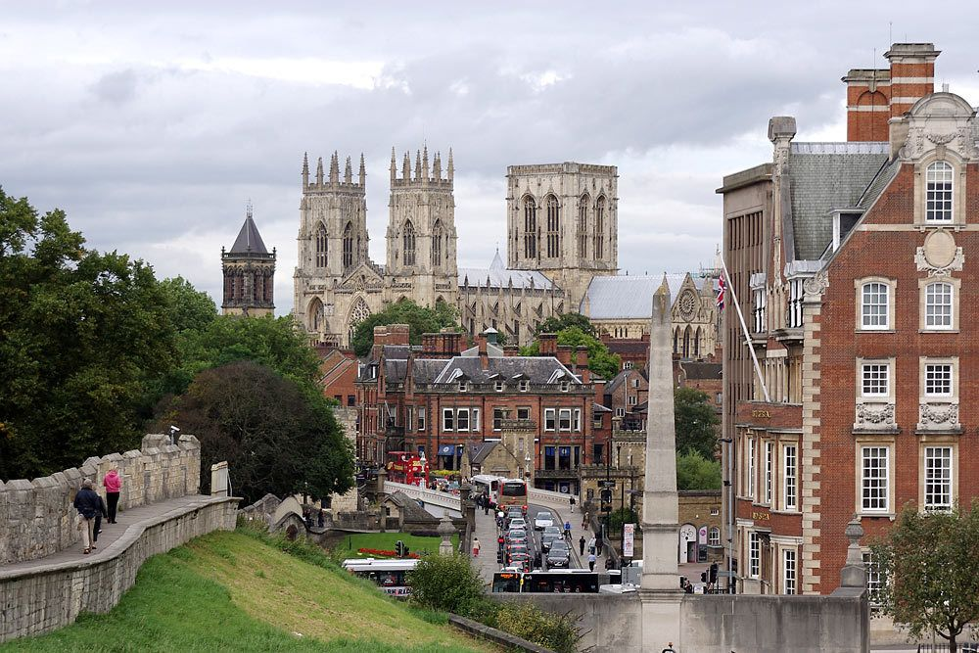 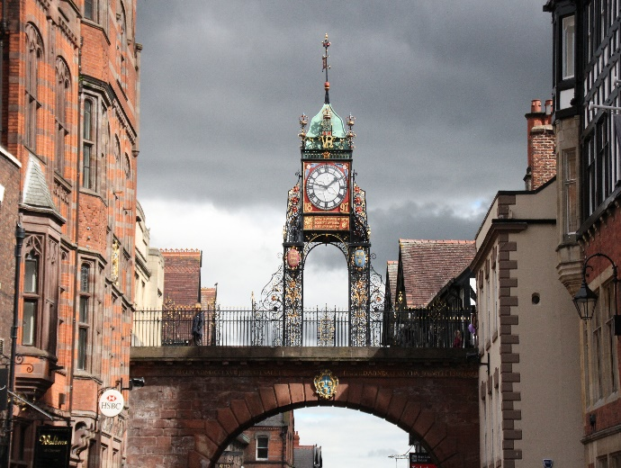

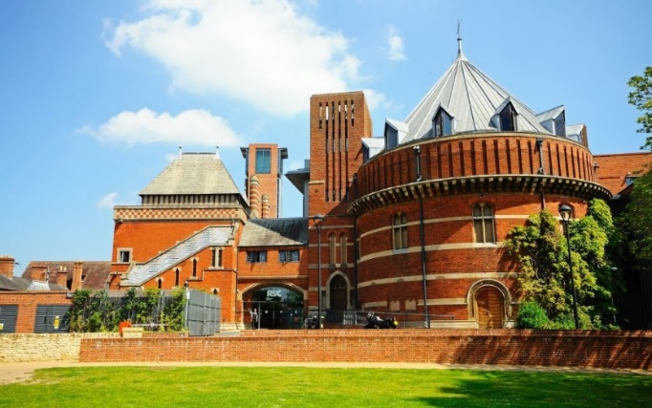 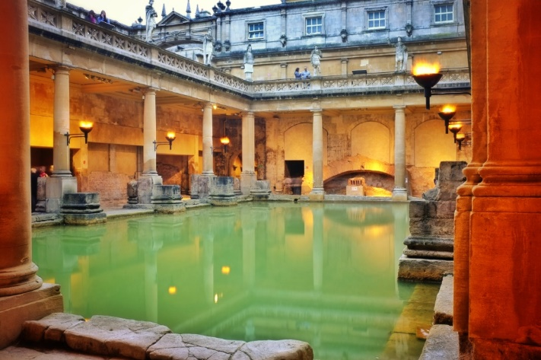

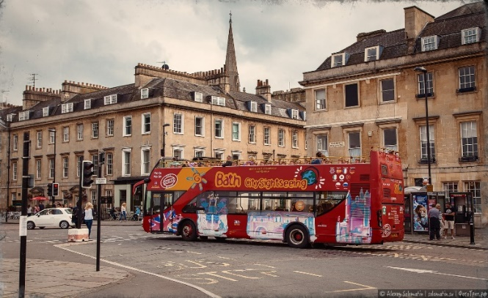 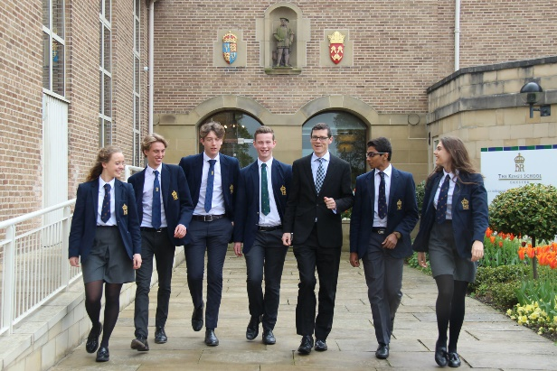

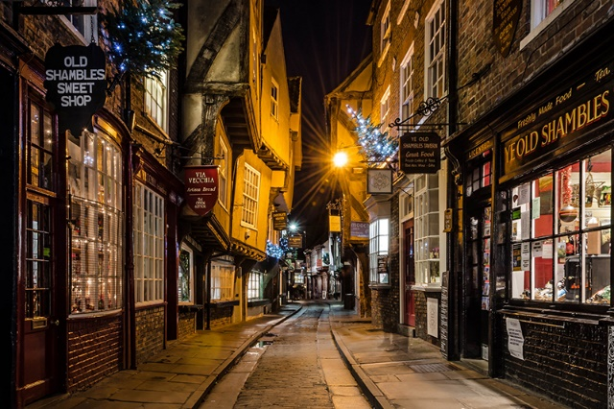 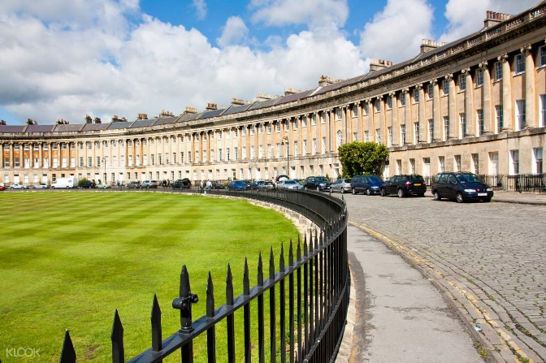

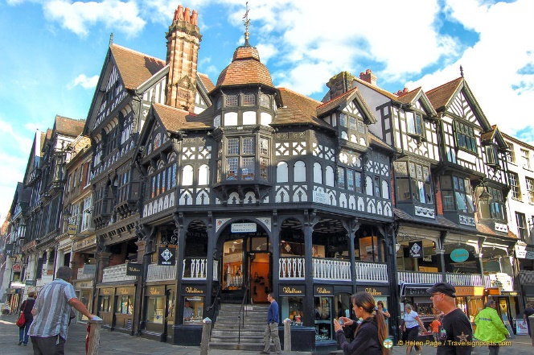 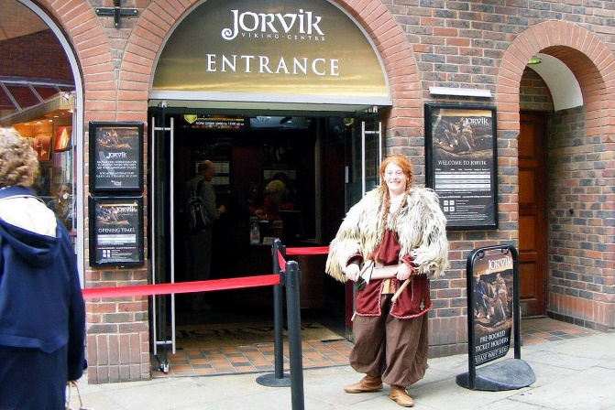

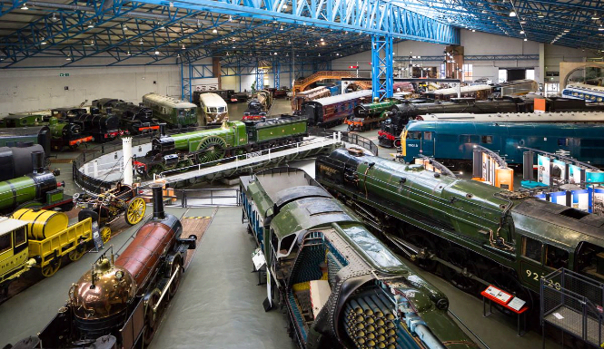 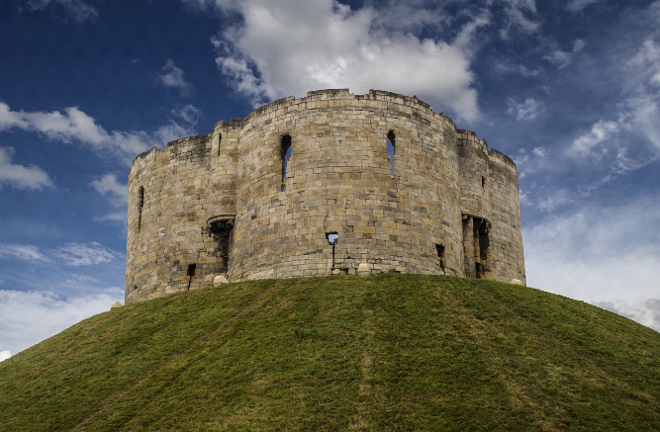

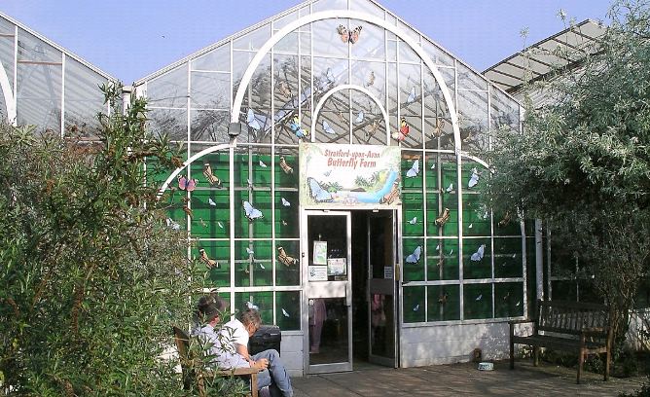 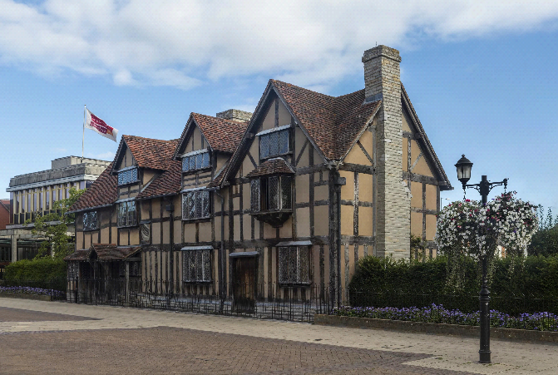

Приложение 7

**Mind Map**

A spa, hot springs

Beautiful architecture

Georgian houses

Art festivals

BATH

Sights

Famous for

The Roman baths

Royal Crescent

90000

South-West England

LOCATION

POPULATION

**Mind Map**

The Eastgate clock

The castle

CHESTER

Sights

The Rows

Famous for

The miniature Railway

The Roman walls

King’s school

80000

North of England

LOCATION

POPULATION

**Mind Map**

Shakespeare’s birthplace

Sights

A butterfly farm

The Royal Shakespeare theatre

Shakespeare’s birthplace

Stradford-upon-Avon

Famous for

Ancient houses

25000

Central England

LOCATION

POPULATION

A church

**Mind Map**

York

The Yorvic Viking center

North of England England

Sights

City Walls

Famous for

The National Railway museum

York castle

The Shambles

200000

LOCATION

POPULATION

A zoo

Приложение 8

**Self-evaluation card**

* I саn recite the poem
* I Know the words
* I саn translate the sentences
* I’ve understood the movie
* I’ve done all exercises
* I can answer the questions
* I can speak about British cities
* I can present a British town